Transaction Stats
Transaction Stats allows you to track how many transactions are being performed.

Stats offers several search options that enable you to narrow down searches to specific criteria.
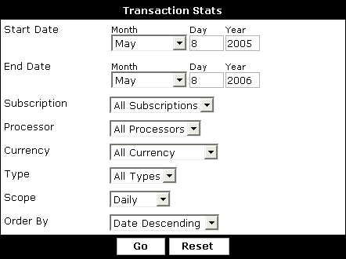
Start Date - Date to limit the oldest transactions to.

End Date - Date to limit the newest transaction to.

Subscription - Include transactions that pertain to all subscriptions or limit transactions to those that pertain to a specific subscription.

Processor - Include transactions that pertain to all payment processors or limit transactions to those that pertain to a specific payment processor.

Currency - Include transactions that pertain to all currencies or limit transactions to those that pertain to a specific currency.

Type - Include charged and reversed transactions or limit to either one.

Order By - Control the order of the resulting stats. List the stats in order of most transaction or in order of date.

Scope - Groups transactions into the chosen option. Example, selecting Monthly would show you how many transaction were performed each month.
Note:
Transactions completed before vBulletin 3.6.0 Beta 1 will contain incomplete information.

